Behavior Adjustment Training (BAT)

for Aggression, Fear and Frustration

Does your dog bark at other dogs? Is she afraid of new people or dogs? Does she seem frustrated if she doesn't get what she wants? This seminar is for you! Diamonds in the Ruff will be hosting this two day seminar co-instructed by certified BAT instructors Carly Loyer and Joey Iverson.


This seminar will give you the tools necessary to work with your dog on resovling problems of fear, frustration and reactivity and help eliminate common behavior problems.

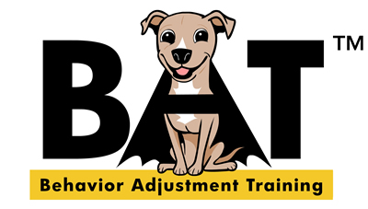
October 4th-5th, 2014 | Spokane WA
Hosted by Diamonds in the Ruff
At SCRAPS, 6815 E. Trent
$199 per person. Early bird-$179!

What is BAT?
When dealing with aggression, fear or frustration, Behaior Adjustment Training (BAT) builds social skills, confidence around the trigger and trust in the handler. While food and other rewards are used with BAT in some cases, the main focus of BAT is giving the dog maximum control in the desensitization process.

This presentation will use video clips with case studies to show how to set up BAT, how to address problems that arise and how to use BAT with other behavior modification techniques. We'll discuss the science behind BAT, the ways this technique is kept low-stress, how to use BAT in the real world and more. You'll also see a live demo with a reactive dog and get some hands-on practice with leash-handling techniques that are essential for training your dog.

Who should attend?
Dog Owners, Trainers, Behaviorists, Shelter and Rescue Staff Members,
Dog Walkers, Daycare Staff and Veterinary Staff.
Seminar is approved for 13 CEUs for CPDT-KA and CPDT-KSA Knowledge.

Registration Details

- This two-day seminar will be held on Saturday/Sunday, Oct 4 - 5, 2014.
- The location of the seminar is at SCRAPS, (6815 E. Trent) in Spokane, WA.
- Registration fee - $199 per person. Early bird registration - $179 - deadline August 31.
Registrations will be taken at the door - $229
Shelter staff/volunteers - register two, get the third free!
- Lunch on your own (a list of nearby restaurants will be provided or bring a sack lunch)
Please contact Cathy at cathy@diamondsintheruff.com for more information or learn more about BAT at www.empoweredanimals.com.

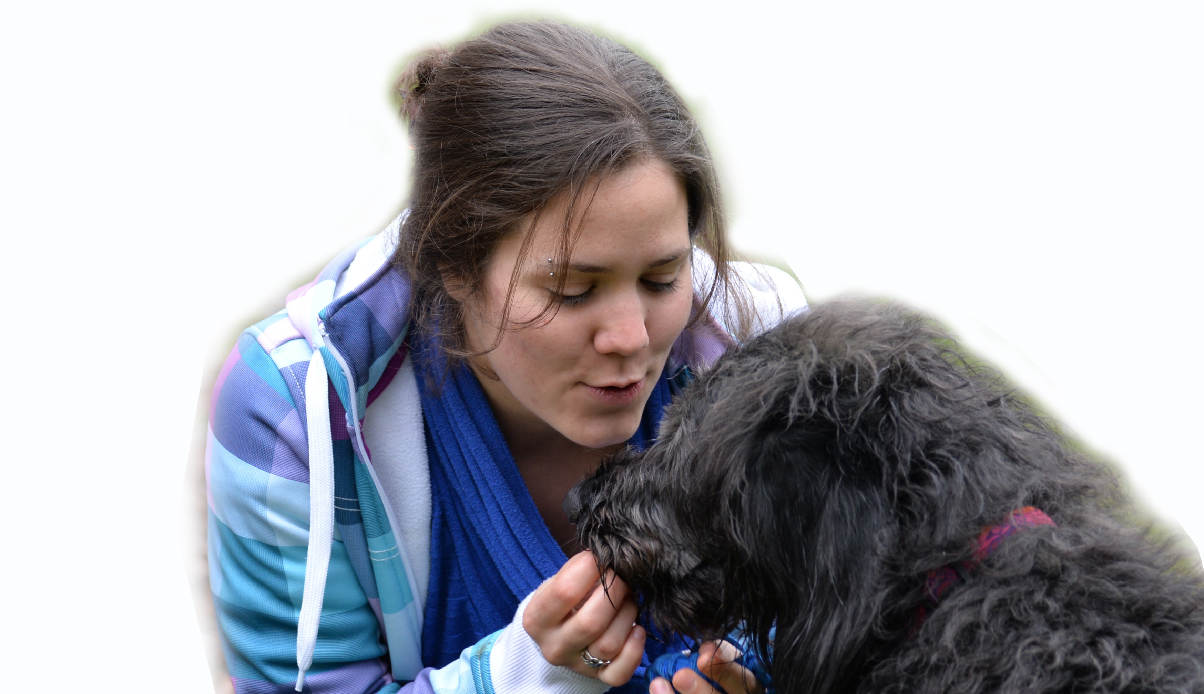
Our co-presenters:

Carly Loyer, CBATI has been training dogs professionally since 2007, and working with Grisha at Ahimsa Dog Training in Seattle since 2008. She is one of the two speakers that Grisha has brought on board to do official 2-day BAT seminars.

Learning, teaching, and dogs are three recurring themes in Carly Loyer’s life. She graduated cum laude from the University of Washington in Seattle with a BA in Psychology, emphasis in animal behavior. She is currently a Ph.D student at UW pursuing research in canine personality.

Carly was also a team leader at the first BAT Instructor’s Course, a team leader at the course in Alaska, and will be a team leader at the 2014 course in Seattle. Carly is also a teaching assistant for some online BAT courses at the Fenzi Dog Sports Academy.

Joey Iversen, CBATI, CPDT, KPACTP is a fun and lively speaker who is well-versed in BAT. Joey is an official speaker for BAT and will be using Grisha Stewart’s slides and videos for this exciting seminar.

With over 16 years experience training and showing both dogs and horses, Joey has worked with all breeds of dogs and their owners. Her calm, patient manner makes it easy for people and dogs to understand and learn from her. Joey received her Certified Pet Dog Trainer title from the Certification Council for Professional Dog Trainers and is a member of the Association of Pet Dog Trainers. She is a graduate of the Karen Pryor Academy for Animal Training and Behavior. According to a company statement, the “Karen Pryor Academy for Animal Training and Behavior is an innovative institution committed to educating,

REGISTRATION

Name _______________________________________________ Phone _________________________
Address _____________________________________________ Email __________________________

City ________________________________________ State ____________ Zip ____________________
Business name/Website ________________________________________________________________
CEU’s needed for ___________________________________
Registration type: (circle one) Amount enclosed $ _______________
Regular $199 Early Bird $179 (deadline 8-31) Shelter – buy 2 get 1 free
Shelter/Rescue name ____________________________________________________________

INCLUDE YOUR CHECK MADE OUT TO DIAMONDS IN THE RUFF AND MAIL TO:
BAT SEMINAR - 1029 W. Dalton Ave, Spokane, WA 99205
To pay via credit card, register online: www.diamondsintheruff.com/#!bat-seminar-oct-4-5-2014/chlb

